dotnet new webapi -n Restaurants.API --no-openapi -controllers

dotnet new sln

dotnet new sln -n Restaurants ---> to custom name

dotnet sln add ./Restaurants.API--->connecting project to solution file

<https://www.youtube.com/watch?v=E6sUJWwZLwE>

Creating and using Services

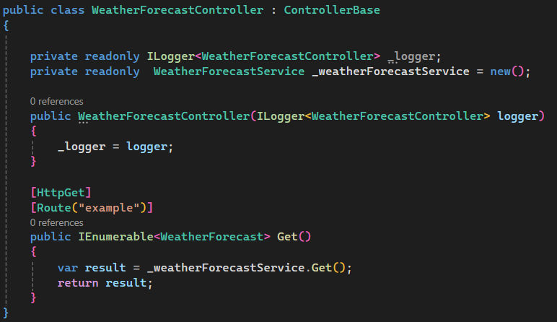

Or

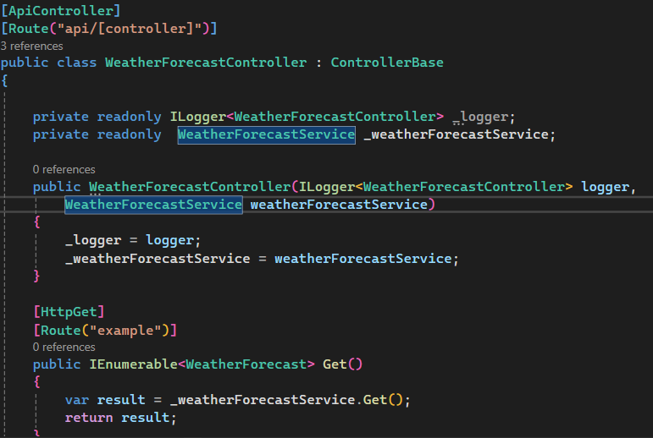

And add in program.cs 🡺 builder.Services.AddScoped<WeatherForecastService>();

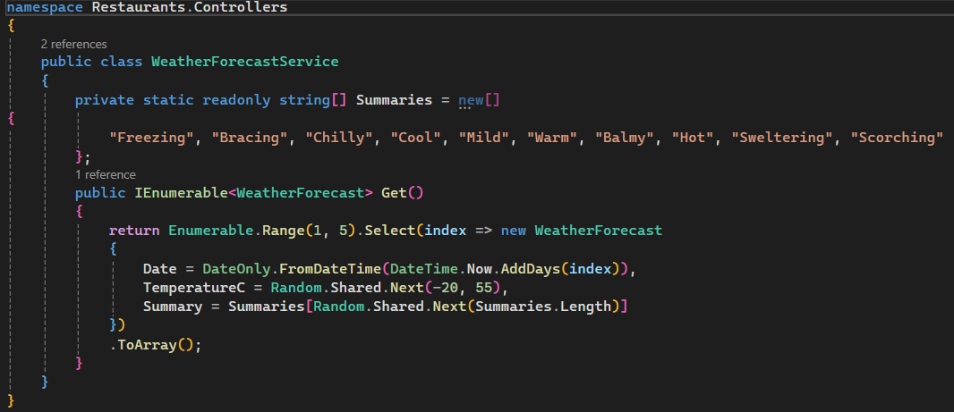

Same Service class but using interface  
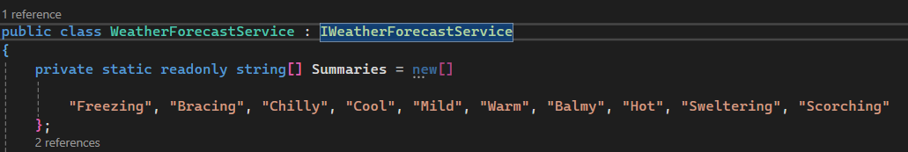  
  
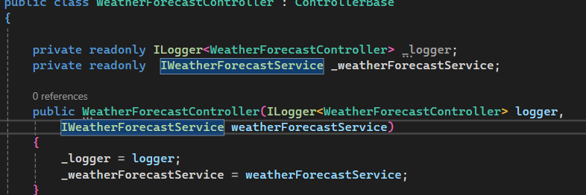

Program.cs  


Adding Route and showing different Request Type (query, path and body)

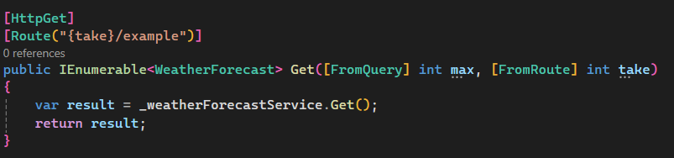

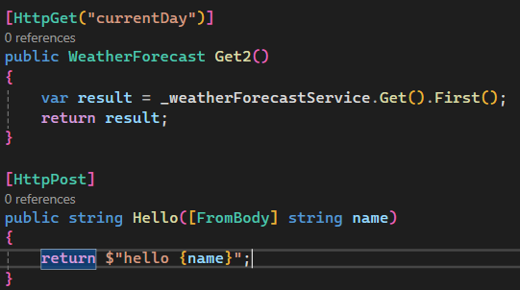

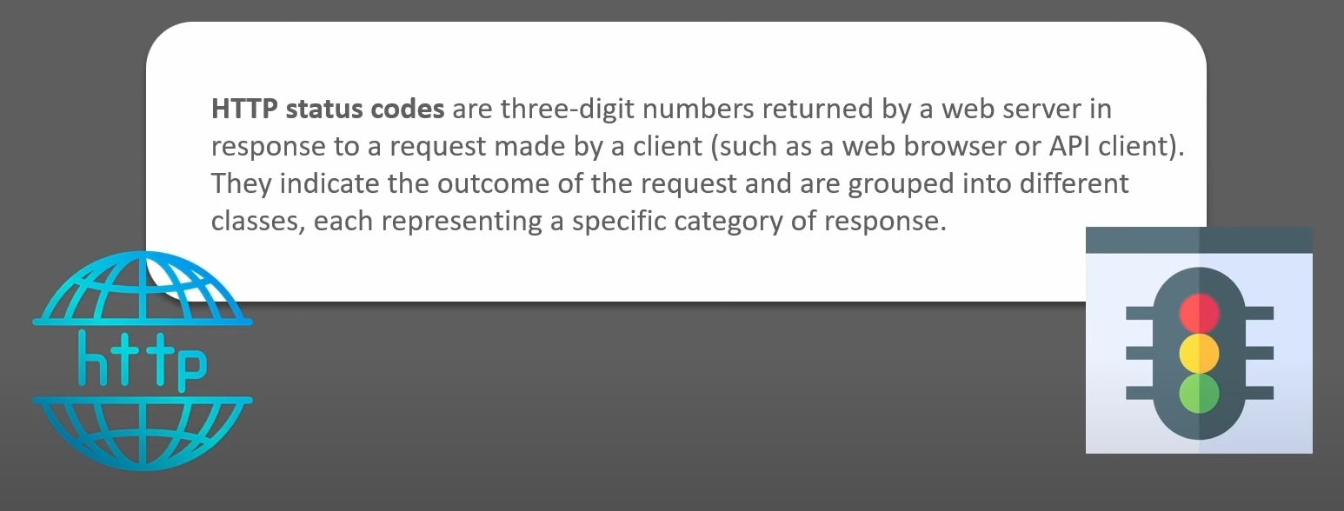

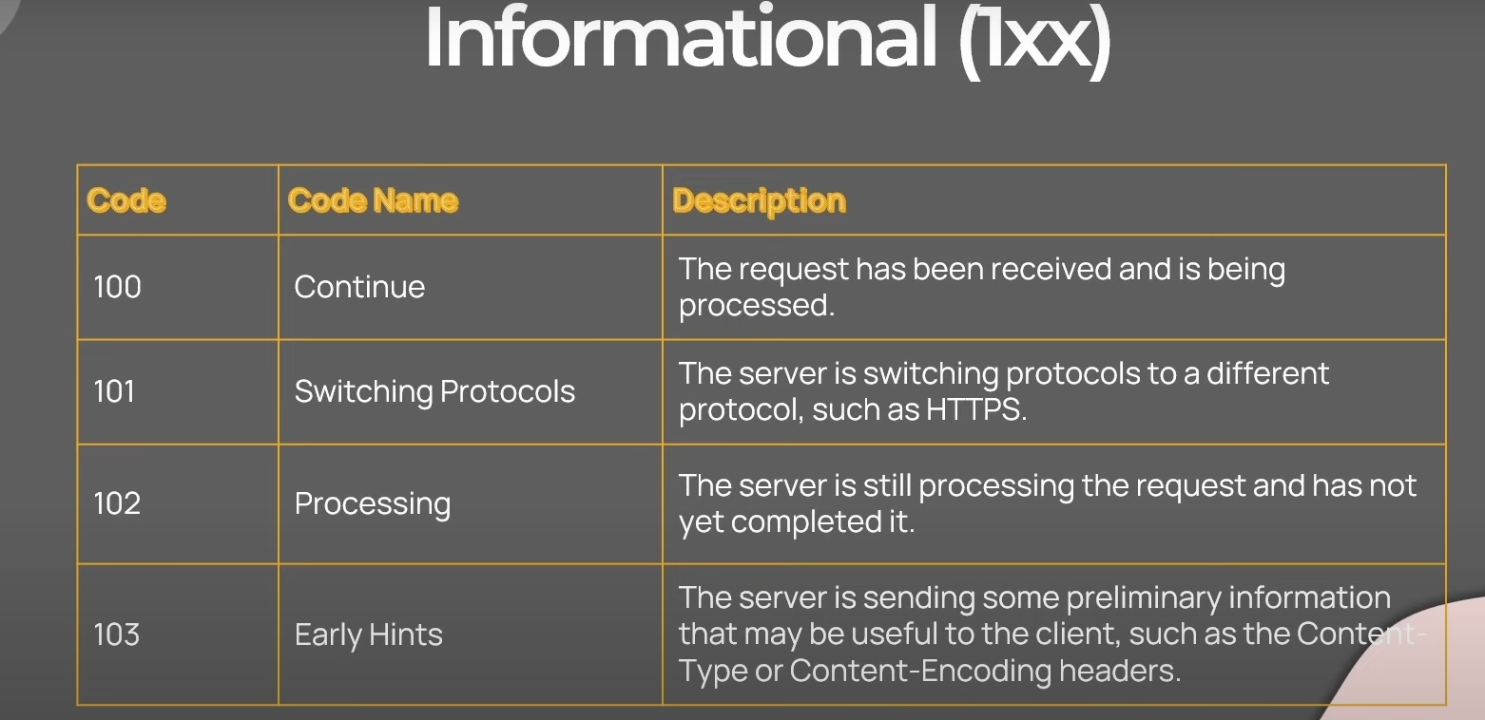

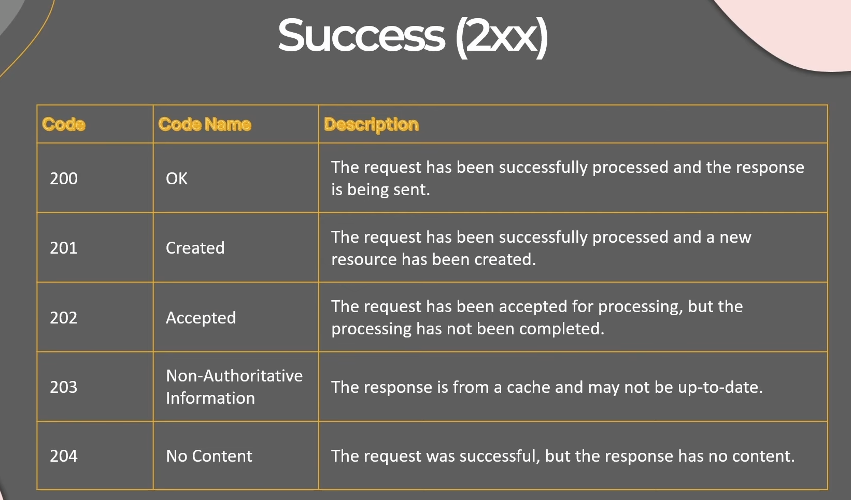

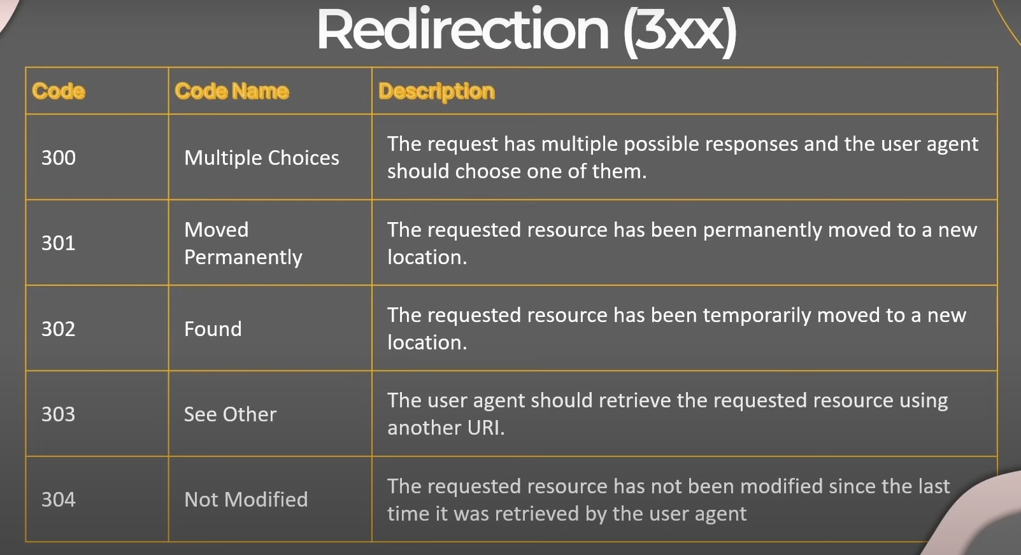

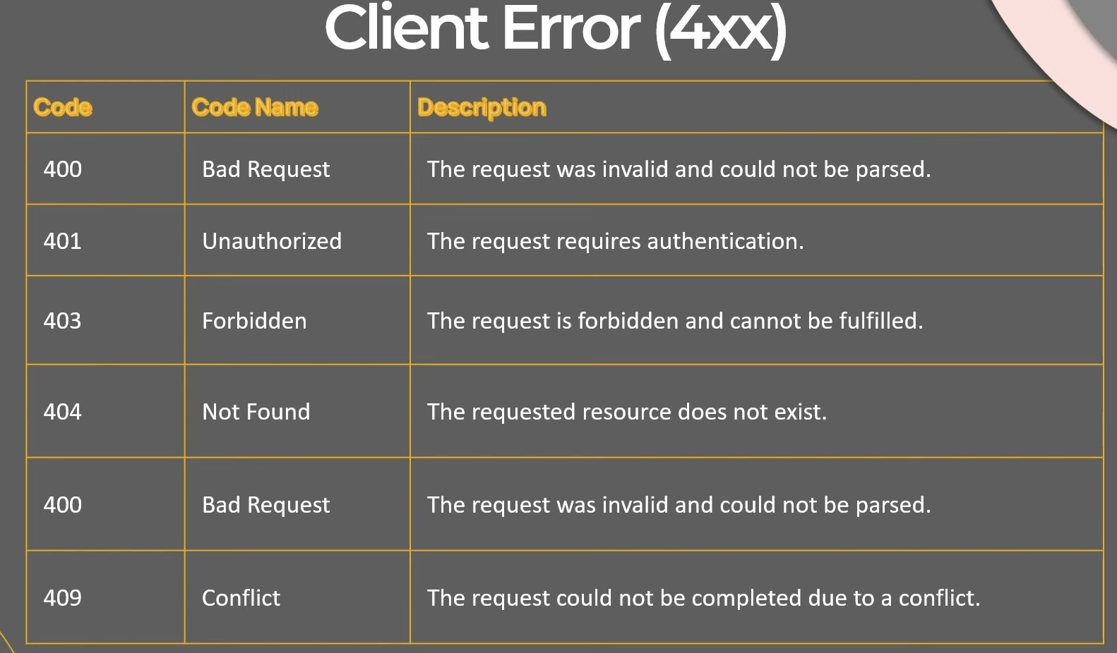

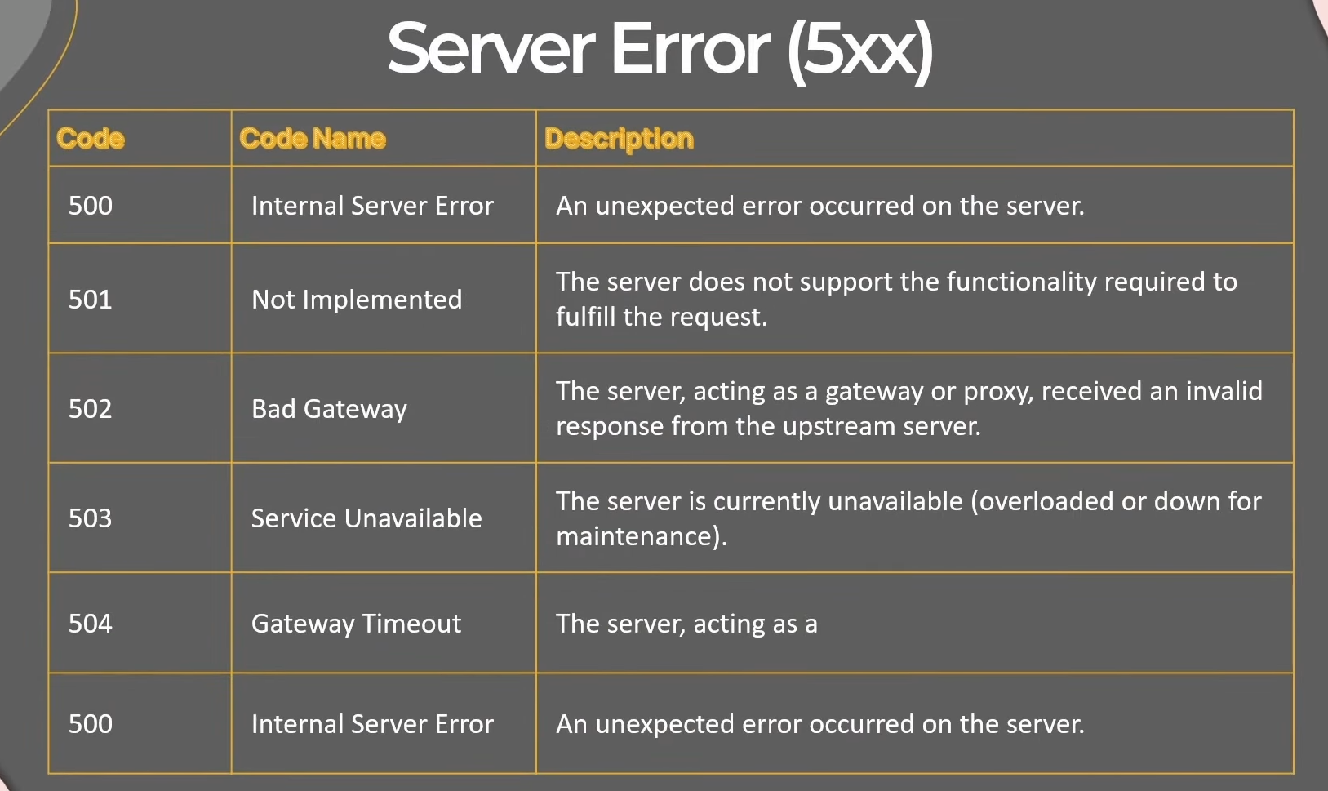

Changing Status Code in controller Response  
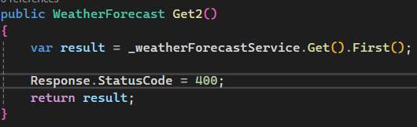 or 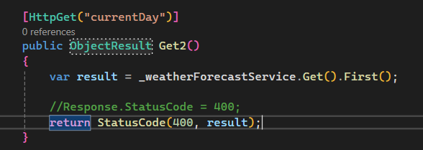

return BadRequest(result); return Ok(result); return Created(result); return NotFound(result);

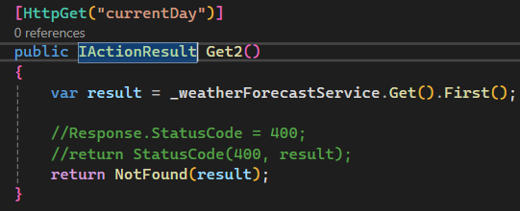

Sample Controller  
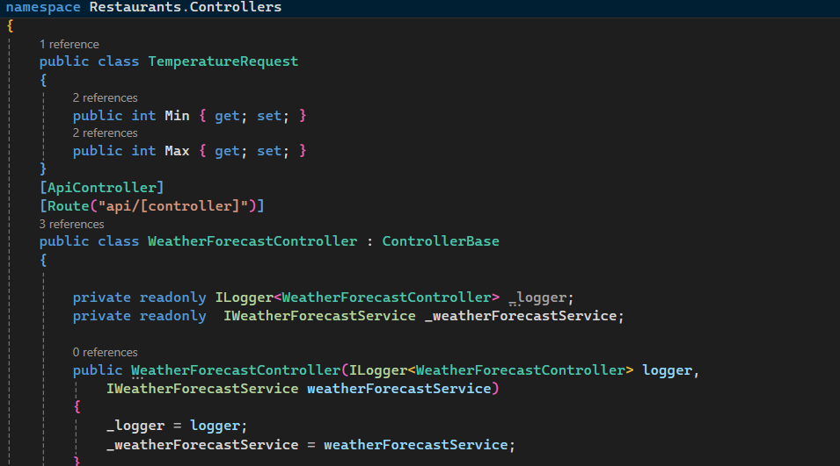

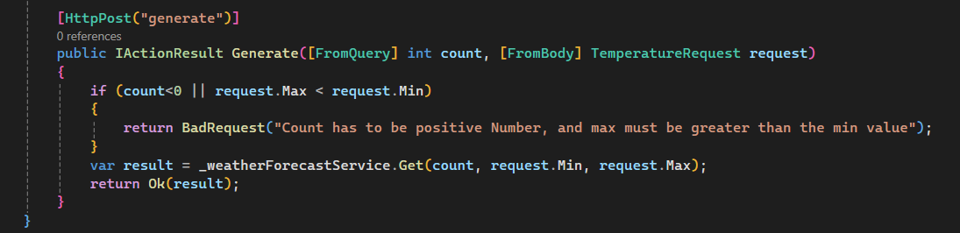

Clean Architecture  
-Domain

-Application

-Presentation and Infrastructure

Add Domain Project to Solution

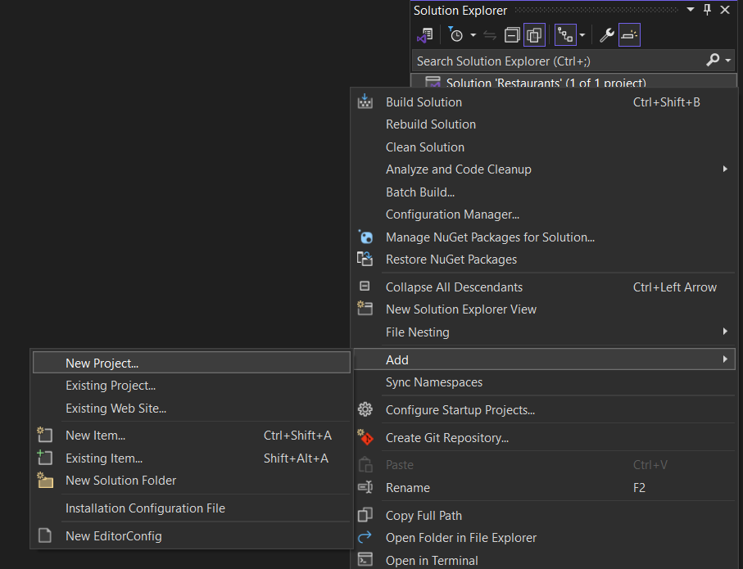  
  
Creater Restaurants.Domain as Class Library

Create Restaurants.Application as Class Library

* Add reference of Domain for Application Dependancy
  + 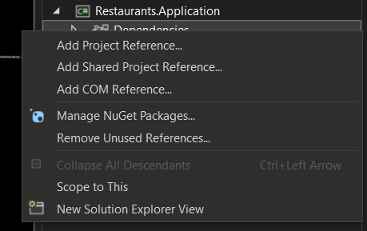
* Add reference of Application for Main Restaurants API dependencies

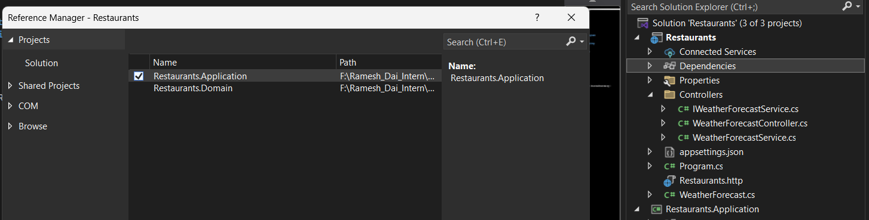

* Add reference of Application for Infrastructure dependencies

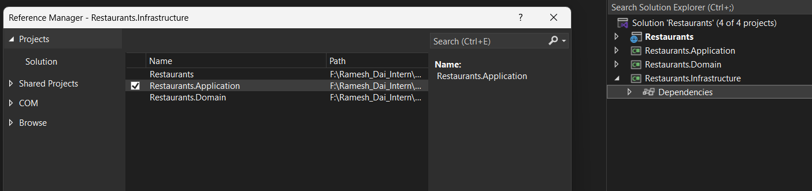  
  
Shift + F2 to create new Folder and new Class

If want to create folder add slash at the end without extension cs

Creating First Entities

namespace Restaurants.Domain.Entities

{

public class Restaurant

{

public int Id { get; set; }

public string Name { get; set; } = default!;

public string Description { get; set; } = default!;

public string Category { get; set; } = default!;

public bool HasDelivery { get; set; }

public string? ContactEmail { get; set; }

public string? ContactNumber { get; set; }

public Address? Address { get; set; }

public List<Dish> Dishes { get; set; } = new();

}

}namespace Restaurants.Domain.Entities

{

public class Address

{

public string? City { get; set; }

public string? Street { get; set; }

public string? PostalCode { get; set; }

}

}namespace Restaurants.Domain.Entities

{

public class Dish

{

public int Id { get; set; }

public string? Name { get; set; } = default!;

public string? Description { get; set; } = default!;

public decimal Price { get; set; }

}

}

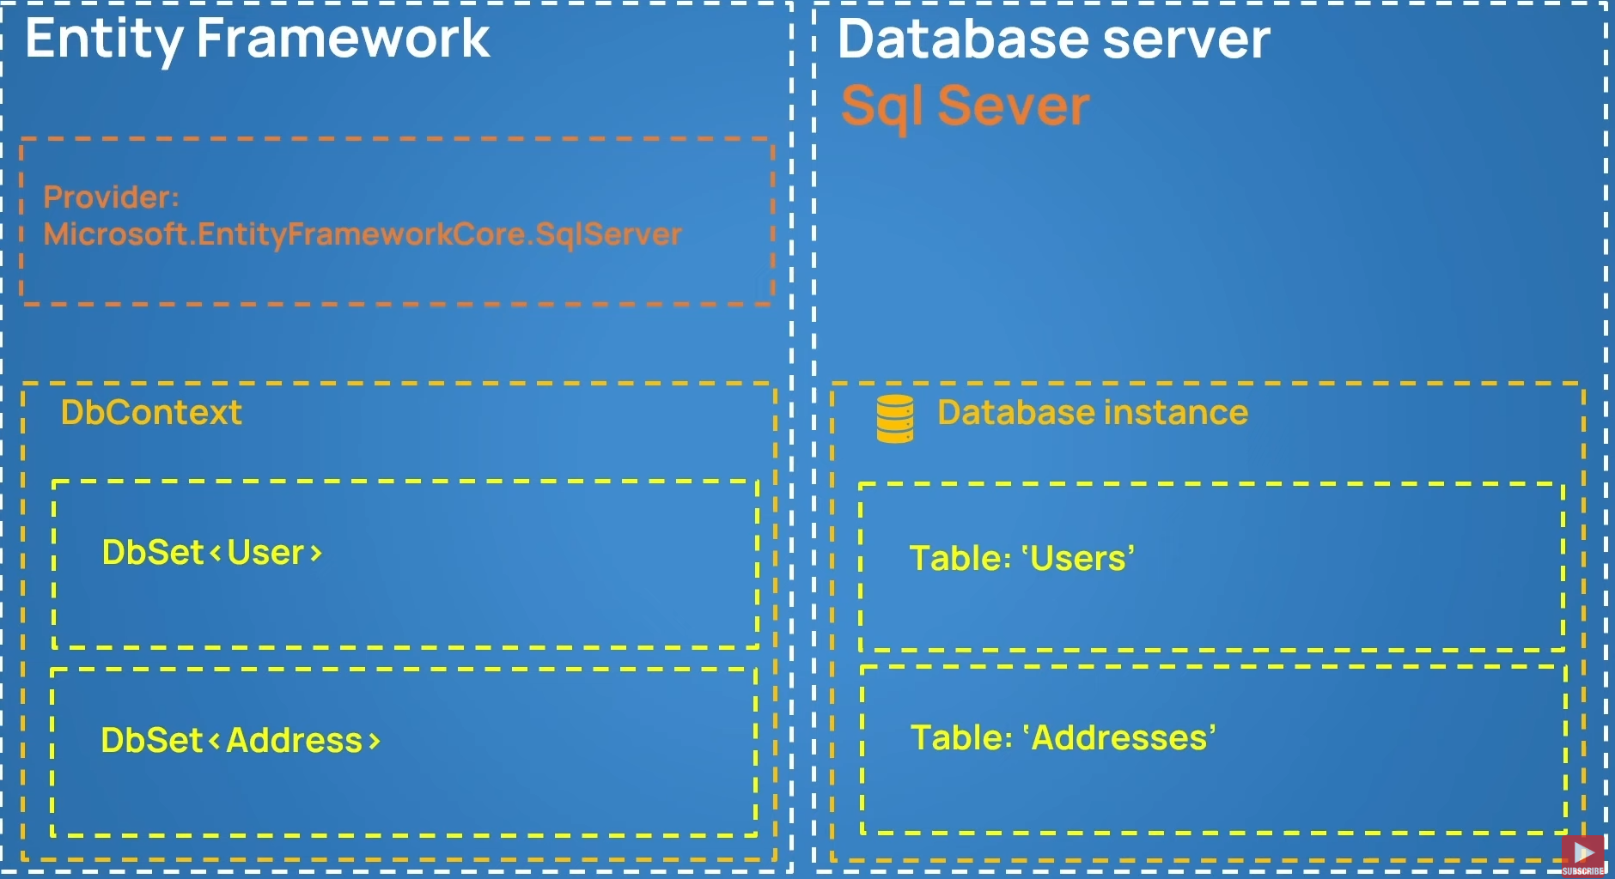

  
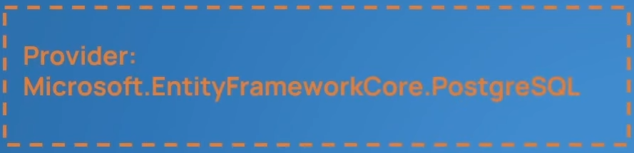

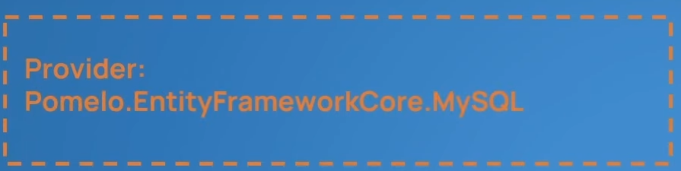

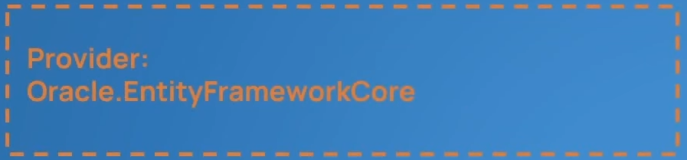

Creating Dbcontext and Registering Tables  
using Microsoft.EntityFrameworkCore;

using Restaurants.Domain.Entities;

namespace Restaurants.Infrastructure.Persistence

{

internal class RestaurantsDbContext : DbContext

{

internal DbSet<Restaurant> Restaurants { get; set; }

internal DbSet<Dish> Dishes { get; set; }

protected override void OnConfiguring(DbContextOptionsBuilder optionsBuilder)

{

optionsBuilder.UseSqlServer("Server=DESKTOP-DMBAGSB\\SQLEXPRESS;Database=RestaurantsDb;Trusted_Connection=True");

}

}

}



Add nugget package in infrastrucuture to perform migrations

Set Restaurants.Infrastructure as startup project  
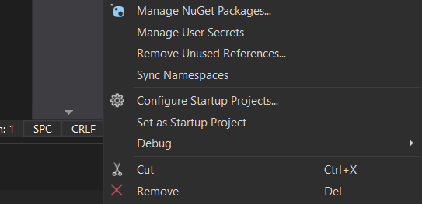  
go to package manager console

And type add-migration intit

Adding Addresstable inside the restaurant

protected override void OnModelCreating(ModelBuilder modelBuilder)

{

base.OnModelCreating(modelBuilder);

modelBuilder.Entity<Restaurant>()

.OwnsOne(r => r.Address);

modelBuilder.Entity<Restaurant>()

.HasMany(r => r.Dishes)

.WithOne()

.HasForeignKey(d => d.RestaurantId);

}

Connecting Infrastructure layer to main presentation layer  
For connecting database   
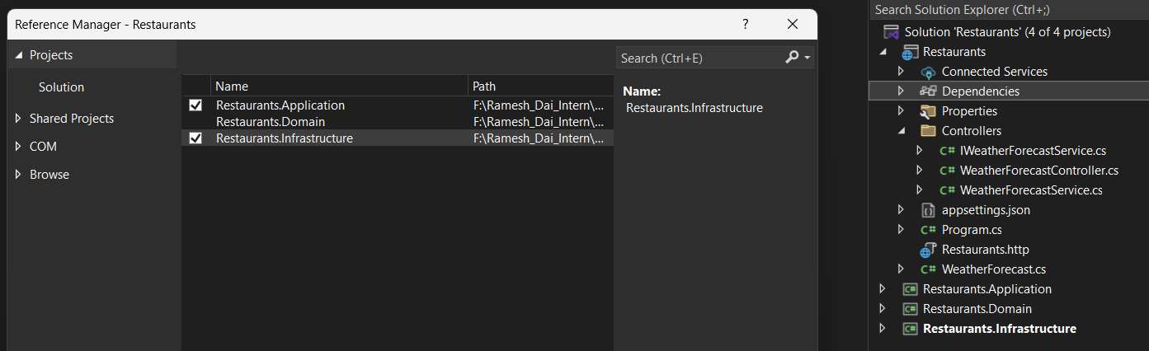

Restaurants.Infrastructure.Extensions/ServiceCollectionExtensions.cs  
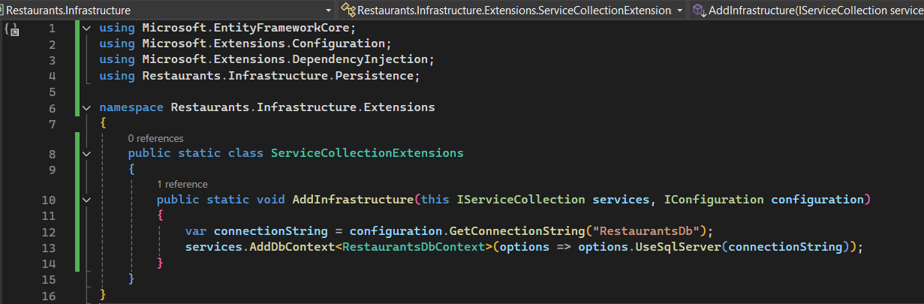

RestaurantDbContext.cs

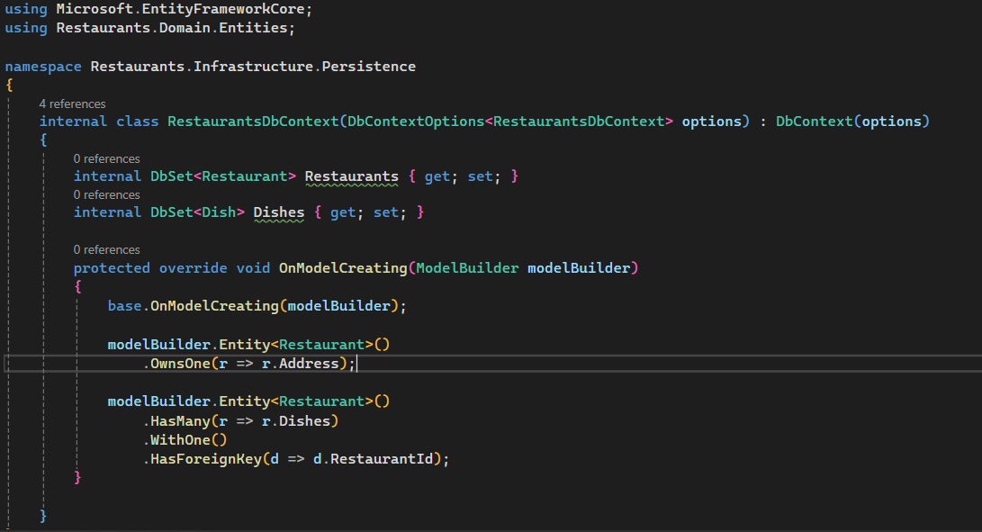

set Restaurants.API as startupProject.

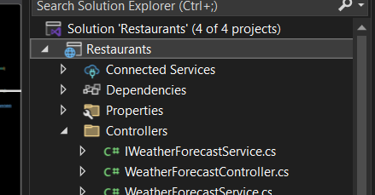  
  
 <ItemGroup>

<PackageReference Include="Microsoft.EntityFrameworkCore.Tools" Version="9.0.6">

<PrivateAssets>all</PrivateAssets>

<IncludeAssets>runtime; build; native; contentfiles; analyzers; buildtransitive</IncludeAssets>

</PackageReference>

</ItemGroup>  
  
Add this to Restaurants to API to be able to update database when restaurants.API is setup as startup Project  
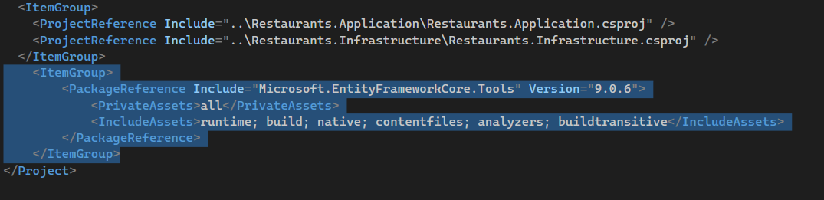  
  
Seeding the Database  
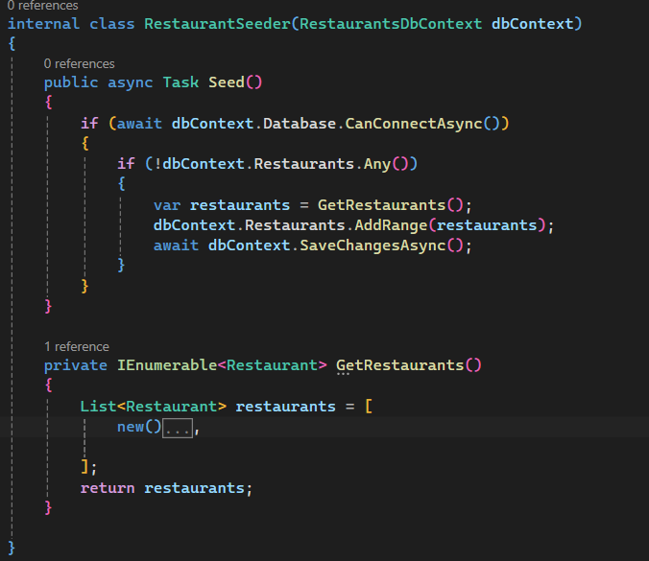

List<Restaurant> restaurants = [

new()

{

Name = "KFC",

Category = "Fast Food",

Description = "KFC is an AMerican food Company",

ContactEmail = "caont@yahoo.com",

HasDelivery = true,

Dishes =

[

new()

{

Name = "Nashville Hot Chicken",

Description = "Nash (10pcs)",

Price = 10.30M,

},

new()

{

Name = "Chicken Nuggets",

Description = "Nuggets (5pcs)",

Price = 5.30M,

},

],

Address = new()

{

City = "London",

Street = "Cork St 5",

PostalCode = "WC2N 5DU",

}

},

];

Also change this

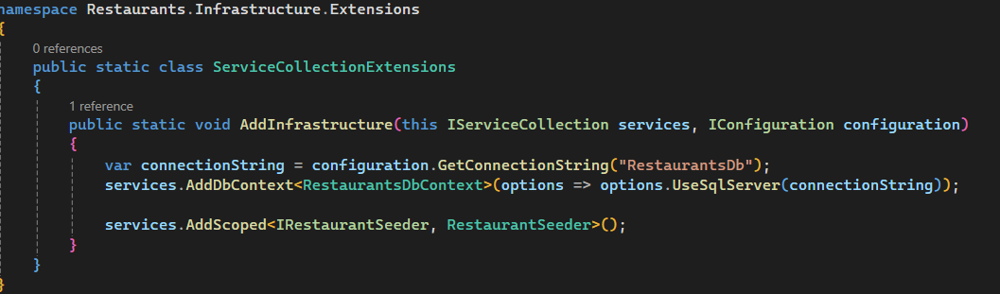

Change this

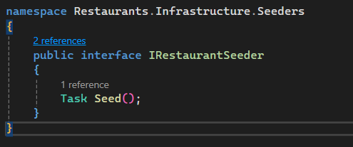

Program.cs

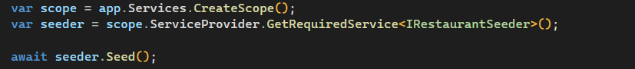

### Chat GPT Code Step-by-Step Plan

**🔧 Step 1: Install Required NuGet Packages**

Run this from the Restaurants (API) root using the terminal:

dotnet add Restaurants.Application package Microsoft.Extensions.DependencyInjection.Abstractions

dotnet add Restaurants.Infrastructure package Microsoft.EntityFrameworkCore

dotnet add Restaurants.Infrastructure package Microsoft.EntityFrameworkCore.SqlServer

dotnet add Restaurants.Infrastructure package Microsoft.EntityFrameworkCore.Tools

dotnet add Restaurants.Infrastructure package Microsoft.AspNetCore.Authentication.JwtBearer

dotnet add Restaurants package Microsoft.AspNetCore.Authentication.JwtBearer

**📁 Folder/Project Layout Reminder**

* Restaurants.Domain: Entities and interfaces
* Restaurants.Application: DTOs, interfaces, services
* Restaurants.Infrastructure: EF Core, services implementation
* Restaurants: API, Controllers, JWT setup

**✅ Step 2: Add Dish DTOs and Interfaces**

**📄 Application/DTOs/DishDto.cs**

namespace Restaurants.Application.DTOs;

public class DishDto

{

public int Id { get; set; }

public string? Name { get; set; }

public string? Description { get; set; }

public decimal Price { get; set; }

}

**✅ Step 3: Create Dish Service Interface**

**📄 Application/Interfaces/IDishService.cs**

using Restaurants.Application.DTOs;

namespace Restaurants.Application.Interfaces;

public interface IDishService

{

Task<IEnumerable<DishDto>> GetAllAsync();

}

**✅ Step 4: Implement Dish Service**

**📄 Infrastructure/Services/DishService.cs**

using Microsoft.EntityFrameworkCore;

using Restaurants.Application.DTOs;

using Restaurants.Application.Interfaces;

using Restaurants.Infrastructure.Persistence;

namespace Restaurants.Infrastructure.Services;

internal class DishService(RestaurantsDbContext dbContext) : IDishService

{

public async Task<IEnumerable<DishDto>> GetAllAsync()

{

return await dbContext.Dishes

.Select(d => new DishDto

{

Id = d.Id,

Name = d.Name,

Description = d.Description,

Price = d.Price

})

.ToListAsync();

}

}

**✅ Step 5: Register DishService in DI**

**📄 Infrastructure/Extensions/ServiceCollectionExtensions.cs**

Add this line:

services.AddScoped<IDishService, DishService>();

Your method becomes:

public static void AddInfrastructure(this IServiceCollection services, IConfiguration configuration)

{

var connectionString = configuration.GetConnectionString("RestaurantsDb");

services.AddDbContext<RestaurantsDbContext>(options => options.UseSqlServer(connectionString));

services.AddScoped<IRestaurantSeeder, RestaurantSeeder>();

services.AddScoped<IDishService, DishService>();

}

**✅ Step 6: Create Controller**

**📄 Restaurants/Controllers/DishesController.cs**

using Microsoft.AspNetCore.Authorization;

using Microsoft.AspNetCore.Mvc;

using Restaurants.Application.Interfaces;

namespace Restaurants.Controllers;

[ApiController]

[Route("api/[controller]")]

[Authorize]

public class DishesController(IDishService dishService) : ControllerBase

{

[HttpGet]

public async Task<IActionResult> Get()

{

var dishes = await dishService.GetAllAsync();

return Ok(dishes);

}

}

**✅ Step 7: JWT Authentication Setup**

**📄 Restaurants/appsettings.json**

"JwtSettings": {

"Issuer": "YourAppIssuer",

"Audience": "YourAppAudience",

"Key": "superSecretKey@345"

}

**📄 Restaurants/Program.cs**

using Microsoft.AspNetCore.Authentication.JwtBearer;

using Microsoft.IdentityModel.Tokens;

using System.Text;

using Restaurants.Infrastructure.Extensions;

var builder = WebApplication.CreateBuilder(args);

// Add services

builder.Services.AddControllers();

builder.Services.AddEndpointsApiExplorer();

builder.Services.AddSwaggerGen();

builder.Services.AddInfrastructure(builder.Configuration);

// JWT Auth

var jwtSettings = builder.Configuration.GetSection("JwtSettings");

builder.Services

.AddAuthentication(JwtBearerDefaults.AuthenticationScheme)

.AddJwtBearer(options =>

{

options.TokenValidationParameters = new TokenValidationParameters

{

ValidateIssuer = true,

ValidateAudience = true,

ValidateLifetime = true,

ValidateIssuerSigningKey = true,

ValidIssuer = jwtSettings["Issuer"],

ValidAudience = jwtSettings["Audience"],

IssuerSigningKey = new SymmetricSecurityKey(Encoding.UTF8.GetBytes(jwtSettings["Key"]!))

};

});

var app = builder.Build();

app.UseSwagger();

app.UseSwaggerUI();

app.UseAuthentication(); // 🔐 Important

app.UseAuthorization();

app.MapControllers();

app.Run();

**✅ Step 8: Create a Token Generator (for testing login)**

You can mock login now.

**📄 Restaurants/Controllers/AuthController.cs**

using Microsoft.AspNetCore.Mvc;

using Microsoft.IdentityModel.Tokens;

using System.IdentityModel.Tokens.Jwt;

using System.Security.Claims;

using System.Text;

namespace Restaurants.Controllers;

[ApiController]

[Route("api/[controller]")]

public class AuthController(IConfiguration configuration) : ControllerBase

{

[HttpPost("login")]

public IActionResult Login([FromBody] LoginRequest request)

{

// Hardcoded for testing

if (request.Username != "admin" || request.Password != "password")

return Unauthorized();

var claims = new[]

{

new Claim(ClaimTypes.NameIdentifier, request.Username),

new Claim(ClaimTypes.Role, "Admin")

};

var key = new SymmetricSecurityKey(Encoding.UTF8.GetBytes(configuration["JwtSettings:Key"]!));

var creds = new SigningCredentials(key, SecurityAlgorithms.HmacSha256);

var token = new JwtSecurityToken(

issuer: configuration["JwtSettings:Issuer"],

audience: configuration["JwtSettings:Audience"],

claims: claims,

expires: DateTime.Now.AddHours(1),

signingCredentials: creds

);

return Ok(new { token = new JwtSecurityTokenHandler().WriteToken(token) });

}

}

public record LoginRequest(string Username, string Password);

**✅ Step 9: Use the API**

1. **Start the API**.
2. **POST** to /api/auth/login with:

{

"username": "admin",

"password": "password"

}

Get the token from response.

1. **Call** GET /api/dishes with:

Authorization: Bearer <your_token>

## Adding USER REGISTER FUNCTION and LOGIN

## 📁 1. Domain Layer (Restaurants.Domain)

### 🧾 Entities/User.cs

namespace Restaurants.Domain.Entities;

public class User

{

public int Id { get; set; }

public string Username { get; set; } = default!;

public string PasswordHash { get; set; } = default!;

}

## 📁 2. Application Layer (Restaurants.Application)

### 🧾 DTOs/RegisterUserDto.cs

namespace Restaurants.Application.DTOs;

public class RegisterUserDto

{

public string Username { get; set; } = default!;

public string Password { get; set; } = default!;

}

### 🧾 DTOs/LoginUserDto.cs

namespace Restaurants.Application.DTOs;

public class LoginUserDto

{

public string Username { get; set; } = default!;

public string Password { get; set; } = default!;

}

### 🧾 Interfaces/IUserService.cs

using Restaurants.Application.DTOs;

namespace Restaurants.Application.Interfaces;

public interface IUserService

{

Task RegisterAsync(RegisterUserDto dto);

Task<string> LoginAsync(LoginUserDto dto);

}

## 📁 3. Infrastructure Layer (Restaurants.Infrastructure)

### 🔧 Update RestaurantsDbContext.cs

public DbSet<User> Users { get; set; } = default!;

### 🧾 Services/UserService.cs

csharp

CopyEdit

using Microsoft.AspNetCore.Identity;

using Microsoft.EntityFrameworkCore;

using Microsoft.Extensions.Configuration;

using Microsoft.IdentityModel.Tokens;

using Restaurants.Application.DTOs;

using Restaurants.Application.Interfaces;

using Restaurants.Domain.Entities;

using Restaurants.Infrastructure.Persistence;

using System.IdentityModel.Tokens.Jwt;

using System.Security.Claims;

using System.Text;

namespace Restaurants.Infrastructure.Services;

internal class UserService(

RestaurantsDbContext dbContext,

IConfiguration configuration,

IPasswordHasher<User> passwordHasher) : IUserService

{

public async Task RegisterAsync(RegisterUserDto dto)

{

if (await dbContext.Users.AnyAsync(u => u.Username == dto.Username))

throw new Exception("User already exists.");

var user = new User

{

Username = dto.Username

};

user.PasswordHash = passwordHasher.HashPassword(user, dto.Password);

dbContext.Users.Add(user);

await dbContext.SaveChangesAsync();

}

public async Task<string> LoginAsync(LoginUserDto dto)

{

var user = await dbContext.Users.FirstOrDefaultAsync(u => u.Username == dto.Username);

if (user is null)

throw new Exception("Invalid username or password.");

var result = passwordHasher.VerifyHashedPassword(user, user.PasswordHash, dto.Password);

if (result == PasswordVerificationResult.Failed)

throw new Exception("Invalid username or password.");

var claims = new[]

{

new Claim(ClaimTypes.NameIdentifier, user.Id.ToString()),

new Claim(ClaimTypes.Name, user.Username)

};

var key = new SymmetricSecurityKey(Encoding.UTF8.GetBytes(configuration["JwtSettings:Key"]!));

var creds = new SigningCredentials(key, SecurityAlgorithms.HmacSha256);

var token = new JwtSecurityToken(

issuer: configuration["JwtSettings:Issuer"],

audience: configuration["JwtSettings:Audience"],

claims: claims,

expires: DateTime.UtcNow.AddHours(1),

signingCredentials: creds);

return new JwtSecurityTokenHandler().WriteToken(token);

}

}

### 🔧 Register the UserService and PasswordHasher

#### 📄 Infrastructure/Extensions/ServiceCollectionExtensions.cs

services.AddScoped<IUserService, UserService>();

services.AddScoped<IPasswordHasher<User>, PasswordHasher<User>>();

## 📁 4. API Layer (Restaurants)

### 🧾 Controllers/AuthController.cs

using Microsoft.AspNetCore.Mvc;

using Restaurants.Application.DTOs;

using Restaurants.Application.Interfaces;

namespace Restaurants.Controllers;

[ApiController]

[Route("api/[controller]")]

public class AuthController(IUserService userService) : ControllerBase

{

[HttpPost("register")]

public async Task<IActionResult> Register([FromBody] RegisterUserDto dto)

{

try

{

await userService.RegisterAsync(dto);

return Ok(new { message = "User registered successfully." });

}

catch (Exception ex)

{

return BadRequest(new { error = ex.Message });

}

}

[HttpPost("login")]

public async Task<IActionResult> Login([FromBody] LoginUserDto dto)

{

try

{

var token = await userService.LoginAsync(dto);

return Ok(new { token });

}

catch (Exception ex)

{

return Unauthorized(new { error = ex.Message });

}

}

}

## 🔧 Final Touches

### 🧾 Add Migration and Update Database

Run the following in the terminal:

dotnet ef migrations add AddUserEntity --project Restaurants.Infrastructure --startup-project Restaurants

dotnet ef database update --project Restaurants.Infrastructure --startup-project Restaurants

## ADDING CRUD

## ✅ Step 1: Update Application Layer

### 📄 IDishService.cs

csharp

CopyEdit

using Restaurants.Application.DTOs;

namespace Restaurants.Application.Interfaces;

public interface IDishService

{

Task<IEnumerable<DishDto>> GetAllAsync(decimal? priceUpto = null);

Task<DishDto?> GetByIdAsync(int id);

Task UpdateAsync(int id, DishDto dto);

Task DeleteAsync(int id);

}

## ✅ Step 2: Update DTO if needed

If you plan to use the same DishDto for reading and updating, it's fine. Otherwise, define separate DTOs like UpdateDishDto. For now, we’ll reuse DishDto.

## ✅ Step 3: Implement in Infrastructure

### 📄 DishService.cs

csharp

CopyEdit

public async Task<IEnumerable<DishDto>> GetAllAsync(decimal? priceUpto = null)

{

var query = dbContext.Dishes.AsQueryable();

if (priceUpto is not null)

query = query.Where(d => d.Price <= priceUpto);

return await query

.Select(d => new DishDto

{

Id = d.Id,

Name = d.Name,

Description = d.Description,

Price = d.Price

})

.ToListAsync();

}

public async Task<DishDto?> GetByIdAsync(int id)

{

var dish = await dbContext.Dishes.FindAsync(id);

if (dish is null) return null;

return new DishDto

{

Id = dish.Id,

Name = dish.Name,

Description = dish.Description,

Price = dish.Price

};

}

public async Task UpdateAsync(int id, DishDto dto)

{

var dish = await dbContext.Dishes.FindAsync(id);

if (dish is null) throw new Exception("Dish not found.");

dish.Name = dto.Name;

dish.Description = dto.Description;

dish.Price = dto.Price;

await dbContext.SaveChangesAsync();

}

public async Task DeleteAsync(int id)

{

var dish = await dbContext.Dishes.FindAsync(id);

if (dish is null) throw new Exception("Dish not found.");

dbContext.Dishes.Remove(dish);

await dbContext.SaveChangesAsync();

}

## ✅ Step 4: Update DishesController

### 📄 DishesController.cs

csharp

CopyEdit

using Microsoft.AspNetCore.Authorization;

using Microsoft.AspNetCore.Mvc;

using Restaurants.Application.DTOs;

using Restaurants.Application.Interfaces;

namespace Restaurants.Controllers;

[ApiController]

[Route("api/[controller]")]

[Authorize]

public class DishesController(IDishService dishService) : ControllerBase

{

[HttpGet]

public async Task<IActionResult> Get([FromQuery] decimal? priceUpto = null)

{

var dishes = await dishService.GetAllAsync(priceUpto);

return Ok(dishes);

}

[HttpGet("{id}")]

public async Task<IActionResult> GetById(int id)

{

var dish = await dishService.GetByIdAsync(id);

if (dish is null) return NotFound();

return Ok(dish);

}

[HttpPut("{id}")]

public async Task<IActionResult> Update(int id, [FromBody] DishDto dto)

{

try

{

await dishService.UpdateAsync(id, dto);

return NoContent();

}

catch (Exception ex)

{

return NotFound(new { error = ex.Message });

}

}

[HttpDelete("{id}")]

public async Task<IActionResult> Delete(int id)

{

try

{

await dishService.DeleteAsync(id);

return NoContent();

}

catch (Exception ex)

{

return NotFound(new { error = ex.Message });

}

}

}

## ✅ Optional: Add Validation (Zod or FluentValidation in future)

You can also define a CreateDishDto and UpdateDishDto to separate read/write concerns, and use validation libraries for better error handling.

## ✅ Step 1: Create CreateDishDto

### 📄 Restaurants.Application/DTOs/CreateDishDto.cs

csharp

CopyEdit

namespace Restaurants.Application.DTOs;

public class CreateDishDto

{

public string Name { get; set; } = default!;

public string Description { get; set; } = default!;

public decimal Price { get; set; }

}

## ✅ Step 2: Update IDishService.cs

csharp

CopyEdit

Task<int> CreateAsync(CreateDishDto dto);

Now IDishService.cs becomes:

csharp

CopyEdit

using Restaurants.Application.DTOs;

namespace Restaurants.Application.Interfaces;

public interface IDishService

{

Task<IEnumerable<DishDto>> GetAllAsync(decimal? priceUpto = null);

Task<DishDto?> GetByIdAsync(int id);

Task UpdateAsync(int id, DishDto dto);

Task DeleteAsync(int id);

Task<int> CreateAsync(CreateDishDto dto);

}

## ✅ Step 3: Implement in DishService.cs

csharp

CopyEdit

public async Task<int> CreateAsync(CreateDishDto dto)

{

var dish = new Dish

{

Name = dto.Name,

Description = dto.Description,

Price = dto.Price,

RestaurantId = 1 // hardcoded for now

};

dbContext.Dishes.Add(dish);

await dbContext.SaveChangesAsync();

return dish.Id;

}

## ✅ Step 4: Update DishesController.cs

csharp

CopyEdit

[HttpPost]

public async Task<IActionResult> Create([FromBody] CreateDishDto dto)

{

var dishId = await dishService.CreateAsync(dto);

return CreatedAtAction(nameof(GetById), new { id = dishId }, new { id = dishId });

}

## ✅ Final DishesController.cs Overview

csharp

CopyEdit

[ApiController]

[Route("api/[controller]")]

[Authorize]

public class DishesController(IDishService dishService) : ControllerBase

{

[HttpGet]

public async Task<IActionResult> Get([FromQuery] decimal? priceUpto = null)

{

var dishes = await dishService.GetAllAsync(priceUpto);

return Ok(dishes);

}

[HttpGet("{id}")]

public async Task<IActionResult> GetById(int id)

{

var dish = await dishService.GetByIdAsync(id);

if (dish is null) return NotFound();

return Ok(dish);

}

[HttpPost]

public async Task<IActionResult> Create([FromBody] CreateDishDto dto)

{

var dishId = await dishService.CreateAsync(dto);

return CreatedAtAction(nameof(GetById), new { id = dishId }, new { id = dishId });

}

[HttpPut("{id}")]

public async Task<IActionResult> Update(int id, [FromBody] DishDto dto)

{

try

{

await dishService.UpdateAsync(id, dto);

return NoContent();

}

catch (Exception ex)

{

return NotFound(new { error = ex.Message });

}

}

[HttpDelete("{id}")]

public async Task<IActionResult> Delete(int id)

{

try

{

await dishService.DeleteAsync(id);

return NoContent();

}

catch (Exception ex)

{

return NotFound(new { error = ex.Message });

}

}

}